The researchers have developed two (2) versions of the game, one is a version where the pathfinding algorithm, HPA\*, is applied and another is an enhancement of the algorithm using navmesh.

To test the problems on the game, follow the instructions listed below:

* Start the game by running “Simulator.exe”.
* Click “Play!”.

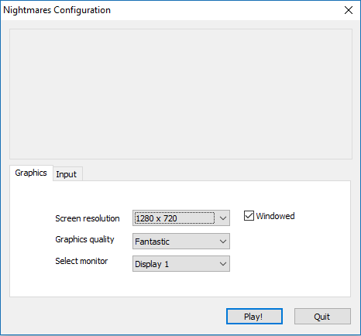

* The screen will then display the area of the game.

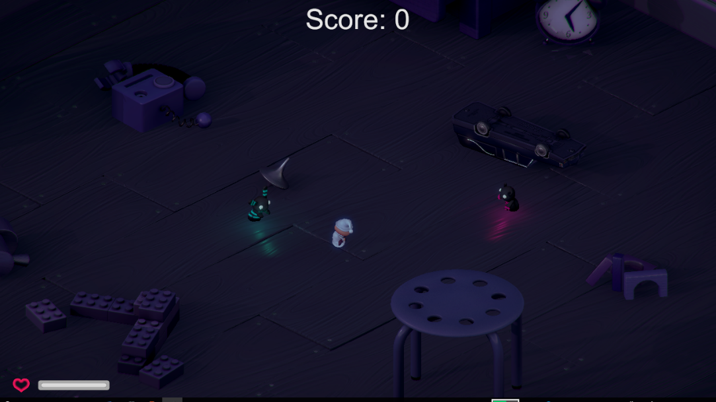

* Move the character by hovering the cursor to your designated destination then click right-click. An alternative to right-clicking is pressing the “Alt” key.